
Stottesdon and Sidbury Parish Council
Clerk: Mrs Freda Morris
18 Glebe Drive
Stottesdon
Kidderminster
Worcs
DY14 8UF

Telephone: 01746 718453
E-mail: stottesdonpc@btinternet.com

Date: 7th November 2011
To: All Parish Council members
The Public and Press Please note change of time and venue

An extraordinary Parish Council meeting will be held on THURSDAY 5th JANUARY 2012 at 7.00pm in STOTTESDON SCHOOL for the transaction of business as set out in the agenda below.

Yours sincerely

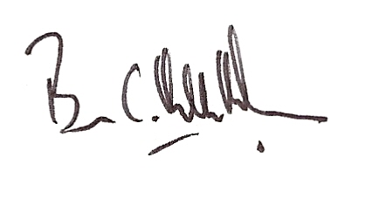

Brian Hamilton-Russell
Chairman - Parish Council

AGENDA

0) Public participation
1) Apologies for absence
2) Declaration of Interests
“To receive declarations of Interest of personal and prejudicial interest on any item on the agenda in accordance with Section 50-52 of the Local Government Act & The Local Authorities (Model Code of Conduct) England Order 2001”.
3) Planning applications:
a) Erection of one agricultural workers dwelling, installation of a septic tank drainage system – The Raysland, Chorley. App. No: 11/05555/FUL
b) Any others received after issue of agenda
4) Date of next meeting – 23rd January 2012

