
Stottesdon and Sidbury Parish Council
Clerk: Mrs Freda Morris
18 Glebe Drive
Stottesdon
Kidderminster
Worcs
DY14 8UF

Telephone: 01746 718453
E-mail: stottesdonpc@btinternet.com

Date: 12th December
To: All Parish Council members
The Public and Press

A Parish Council meeting will be held on MONDAY 20th DECEMBER 2010 at 7.30pm in CHORLEY VILLAGE HALL for the transaction of business as set out in the agenda below.

Yours sincerely

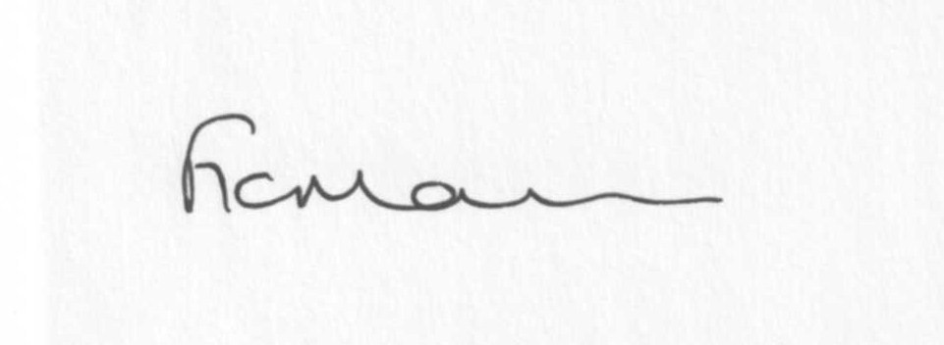
Mrs F Morris
Clerk to the Parish Council

AGENDA

0) Public participation
1) Apologies for absence
2) Declaration of Interests
“To receive declarations of Interest of personal and prejudicial interest on any item on the agenda in accordance with Section 50-52 of the Local Government Act & The Local Authorities (Model Code of Conduct) England Order 2001”.
3) To confirm minutes of the meeting held on 22nd November 2010 (copy attached)
4) Matters Arising from the minutes
(a) Progress report - distributed at meeting
(b) Update re: Broadplace
5) Planning applications: a) Any received after issue of agenda
b) Planning consents – as per SC emails
6) Correspondence:
Beacon Hill Landscapes – Highway Maintenance
Severn Valley Christmas events
SC – Draft Supplementary Planning Document (SPD) on the type and affordability of housing – see SC website (follow link Environment & Planning>Panning>Planning Policy>SPD: affordable housing
Hope House newsletter/funding request
NHS – newsletter A Healthier Future
Came and Company Parish Matters newsletter
Queen’s Diamond Jubilee Preparation letter from HM Lord-Lieutenant of Shropshire
SPFA Newsletter
Glasdon brochure
LCR magazine
ICO receipt for subscription renewal
HM Revenue and Customs – information re: filing PAYE online
Bank statement
Emails forwarded since last meeting
Any others received after the issue of the agenda
7) Parish matters/problems
a) Parish problems
b) Parish Watch
8) Financial matters
a) Outstanding payments: Clerks fees. SLCC membership renewal. Any other accounts received after issue of agenda
b) Income since last meeting - list distributed at meeting
c) Precept – papers distributed at last meeting
9) West Midlands Ambulance Consultation – Plans for becoming a NHS Foundation Trust
10) Website policy
11) ALC report
12) Shropshire Councillor’s report
13) Items for next agenda
14) Date of next meeting - 24th January 2011

Reminder

Deadline for items for next newsletter is 12 noon 4th January 2011

Proposed dates for 2011 meetings:
January 24th
February 28th
March 28th
April 11th Annual Parish meeting
April 18th
May 23rd
June 27th
July 25th
August 22nd
September 26th
October 24th
November 28th
December 19th

