
Stottesdon and Sidbury Parish Council
Clerk: Mrs Freda Morris
18 Glebe Drive
Stottesdon
Kidderminster
Worcs
DY14 8UF

Telephone: 01746 718453
E-mail: stottesdonpc@btinternet.com

Date: 21st February 2011
To: All Parish Council members
The Public and Press

A Parish Council meeting will be held on MONDAY 28th February 2011 at 7.30pm in CHORLEY VILLAGE HALL for the transaction of business as set out in the agenda below.

Yours sincerely
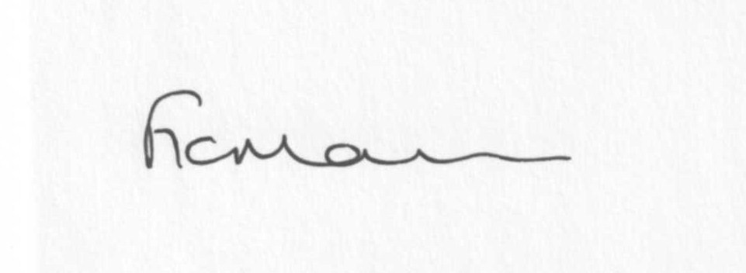
Mrs F Morris
Clerk to the Parish Council

AGENDA

0) Public participation
1) Apologies for absence
2) Declaration of Interests
“To receive declarations of Interest of personal and prejudicial interest on any item on the agenda in accordance with Section 50-52 of the Local Government Act & The Local Authorities (Model Code of Conduct) England Order 2001”.
3) To confirm minutes of the meeting held on January 10th 2011(copy attached)
4) Matters Arising from the minutes
(a) Progress report (distributed at meeting)
(b) Jubilee Celebration feedback
(c) Any other matters arising
5) Planning applications:
a) To confirm applications dealt with since last meeting:
1: To fell 1 Norway Spruce and prune lower branches and selectively reduce width of 1 Oak tree
Within Conservation Area - 18 Glebe Drive, Stottesdon
2: Alterations to and upgrade of a group of timber panels affected Grade II Listed Building – The
Cottage, Lower Chorley Farm, Chorley
b) Application under Section 73a Town & Country Planning Act for change of use from equestrian
purposes to agricultural contractors storage (B8) and alterations to existing site access
(Retrospective) – land adjacent Crown Cottages, Bagginswood.
c) Erection of an agricultural building for the storage of grain – Upper Bardley, Stottesdon – for
information only.
d) Any others received after issue of agenda
e) Planning permissions granted
6) Correspondence:
SC – Local Council Involvement in Minor Highway and Environmental Maintenance contract
Receipt re: Northwood Lane sign
WM Ambulance Service acknowledgement letter
James Dean Pottery leaflet – Royal Wedding commemorative mugs
Crucial Crew funding request
Bank statement
Shrewsbury Park and Ride
Emails:
See attached sheet
Any others received after the issue of the agenda
7) Parish matters/problems
a) Parish problems
b) Parish Watch
8) Financial matters
a) Outstanding payments - Clerk’s fees, Parish Online renewal fee. Any others received after issue of agenda
b) Income since last meeting (list distributed at meeting)
c) Asset Register
9) Website policy
10) Road name signs
11) The Queen Elizabeth II Fields Challenge – details forwarded via email
12) ALC report
13) Shropshire Councillor’s report
14) Items for next agenda
15) Date of next meeting – 28th March 2011

Parish Council meeting – 28th February 2011
Emails forwarded to Councillors since last meeting:
Rural Watch newsletter
Reply from SC re: gritting Stottesdon/Cleobury North road
“ “ “ re: parish problems reported from last meeting
SC – Dog Control Orders – information passed for consideration and action
Weekly Planning lists
Flood forum Update meeting – info
ALC – Cancellation of Retirement Process and the removal of default retirement age
Rural Services Network newsletter
ALC – ICT and future provision
ALC – Consultations
SC – Highways reporting matters
SC – parish problems
SC – speed limit costs for Chorley and Sidbury
Tourism in the Shropshire Hills and Ludlow
ALC – Buckingham Palace Garden Party 19/7/11
Zurich Insurance quotation request
Sustainable Communities Act
TCPA Neighbourhood Planning conference – 29/3/11 – London
Crime in your Area – www.police.uk
ALC – On site training
ALC – Proposed changes to the organisation and funding of schools
SC – Hardwick Bridge damage
ALC – Case studies
SC – Tractor run – 15/5/11
ALC – Info from NALC – ‘What’s Localism’ and NALC launches new good practice materials
SC – Street Party process details
Jane Gibson - Ofcam (re: broadband)
SC – Flood Monitor scheme
Iain Duncan Smith – Our welfare reforms will make work pay
ALC – Parish Councils PAYE
ALC – Transparency Consultation
ALC – Byelaws

