
Stottesdon and Sidbury Parish Council
Clerk: Mrs Freda Morris
18 Glebe Drive
Stottesdon
Kidderminster
Worcs
DY14 8UF

Telephone: 01746 718453
E-mail: stottesdonpc@btinternet.com

Date: 19th January 2015
To: All Parish Council members
The Public and Press

A Parish Council meeting will be held on MONDAY 26th January 2015 at 7.30pm in CHORLEY VILLAGE HALL for the transaction of business as set out in the agenda below which you are summoned to attend.

Yours sincerely
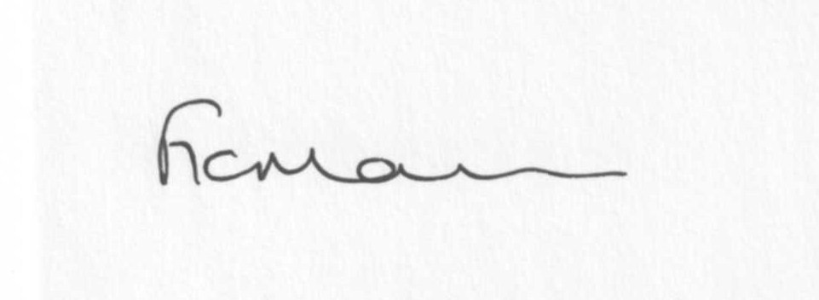
Mrs F Morris
Clerk to the Parish Council

AGENDA

0) Public participation (maximum 15 minutes)
1) Apologies for absence
2) Declaration of Interests
The Localism Act 2011, Relevant Authorities (Disclosable Pecuniary Interests) Regulations 2012.
Members are reminded that they are required to leave the room during the discussion and voting on matters in which they have a disclosable pecuniary interest, whether or not the interest is entered in the register of member’s interests maintained by the Monitoring Officer.
3) To confirm minutes of the meeting held on December 15th 2014 (copy attached)
4) Matters Arising from the minutes
(a) Progress report (distributed at meeting)
(b) Reply from SC re: parish problems/CIL payments
(c) Reply re: car rallies
(d)Any other matters arising
5) a) Co-option of new Councillor
b) Signing of declaration of Acceptance of Office by newly elected Councillor
6) Planning applications:
a) If any received after issue of the agenda
b) Planning permissions/refusals:
1) Reference: 14/05315/TCA (validated: 25/11/2014)
Address: Stottesdon C E Primary School, Stottesdon, Kidderminster, Shropshire, DY14 8UE
Proposal: To remove all major deadwood more than 80mm in diameter and stubbs from throughout the crown of 1No Poplar Lombardy (21) within Stottesdon Conservation Area
Decision: No Objection

2) Reference: 14/05315/TCA (validated: 25/11/2014)
Address: Stottesdon C E Primary School, Stottesdon, Kidderminster, Shropshire, DY14 8UE
Proposal: To remove all major deadwood more than 80mm in diameter and stubbs from throughout the crown of 1No Poplar Lombardy (21) within Stottesdon Conservation Area
Decision: No Objection

3)Reference: 14/04131/FUL (validated: 13/10/2014)
Address: Bagginswood Cottage , Bagginswood, Stottesdon, Kidderminster, DY14 8NA
Proposal: Erection of a single storey side extension together with conversion of double garage with pitched roof over
Decision: Grant Permission
c) Any others received after issue of the agenda
7) SALC report
8) Unitary Councillor’s report
9) Financial matters:
a) Outstanding payments: Clerks fees/HMRC PAYE, M Pearce (mowing of footpaths)
Any others received after issue of the agenda
b) Income since last meeting - confirmed at meeting
c) Bank statement/Quarterly Bank reconciliation/Budget
d) To consider precept requirement for next meeting
e) Proposal by SC to withdraw the Council Tax Support Grant
10) Parish matters/problems
a) Parish problems
b) Parish Watch
11) Correspondence:
Emails forwarded include:
SALC Bulletins
RSN newsletters
Rural Hub newsletter
SC – Electoral Roll
SC – Highways severe weather/potholing schemes - ongoing programme of planned road closures.
CTSG – meeting 9th February at Shirehall
Emergency Planning newsletter
Reply from Cleeview Bridleways Group re: donation
Police and Crime Commissioners newsletter
SALC – Community Health News
Footpath problem reported – forwarded to P3 group for their attention
Outdoor Recreation (SC) – Playground inspection and maintenance service
Reply from Cleeview Bridleways Group re: donation
Police and Crime Commissioners newsletter
SALC – Community Health News
Footpath problem reported – forwarded to P3 group for their attention
Cancellation of LJC Planning meeting – 22nd January
NHS Future Fit
SALC AGM/Conference
Forthcoming road closures:
Road to be closed: Walkerslow Bridge - Overton Junction to the Baytree junction, Burwarton, Shropshire
Date and duration: 02/03/2015 - 4 days (08.00 - 16.00)
Purpose: Bridge Maintenance Works
Applicant: Ringway

Road to be closed: Honeysuckle Junction to The Miners Junction, Stottesdon, Shropshire
Date and duration: 23/02/2015 for 4 days (09.30 - 16.00)
Purpose: Carriageway Resurfacing
Applicant: Ringway

Road to be closed: New Road, Highley
Date: 7th February 2015 for 16 days
(7th and 8th Feb closure 08.00 to 18.00, 14th – 22nd Feb closure 24 hours)
Applicant: Ringway on behalf of Shropshire Council

Any others received after issue of the agenda
12) Date of next meeting: 16th or 23rd February, 2015. Future dates to be agreed.
13) Update: Car parking/playing field ** - if anything to report.
**Due to the confidential nature of the business to be discussed under item 13 the public and press shall be excluded under s1 (2) Public Bodies (Admission to Meetings) Act 1960 as amended

