
Stottesdon and Sidbury Parish Council
Clerk: Mrs Freda Morris
18 Glebe Drive
Stottesdon
Kidderminster
Worcs
DY14 8UF

Telephone: 01746 718453
E-mail: stottesdonpc@btinternet.com

Date: 17th November 2013
To: All Parish Council members
The Public and Press

A Parish Council meeting will be held on MONDAY 25th NOVEMBER 2013 at 7.30pm in CHORLEY VILLAGE HALL for the transaction of business as set out in the agenda below which you are summoned to attend.

Yours sincerely

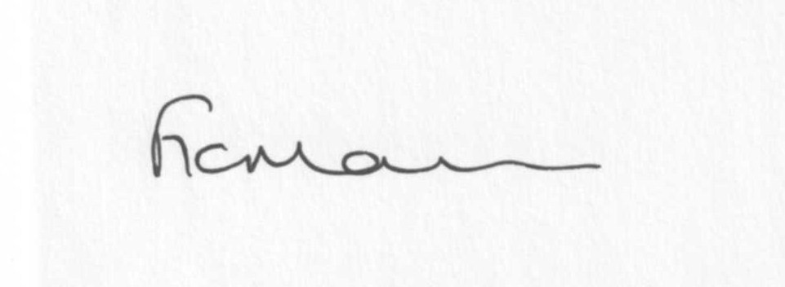

Mrs F Morris
Clerk to the Parish Council

AGENDA

0) Public participation (maximum 15 minutes)
1) Apologies for absence
2) Declaration of Interests
The Localism Act 2011, Relevant Authorities (Disclosable Pecuniary Interests) Regulations 2012.
Members are reminded that they are required to leave the room during the discussion and voting on matters in which they have a disclosable pecuniary interest, whether or not the interest is entered in the register of member’s interests maintained by the Monitoring Officer.
3) To confirm minutes of the meeting held on 23rd October 2013 (copy attached)
4) Matters Arising from the minutes
(a) Progress report (distributed at meeting)
(b) Reply from SC re: parish problems
(c)Any other matters arising
5) School Bus
6) Planning applications:
a) Reference: 13/04446/FUL (validated: 07/11/2013)
Address: Bardley Court Cottage, Stottesdon, Kidderminster, Shropshire, DY14 8NE
Proposal: Erection of a two storey rear extension and alterations
Applicant: Mr Jonathan Hill

b) Town and Country Planning Act 1990 – For information only:
Planning reference: 13/04453/AGR
Development proposed: Erection of an agricultural building
Location: Manor Fields, Stottesdon, Worcestershire, DY14 8TN
OS reference: 266420 – 282207
Applicant: Mr Mike Evans

c) Any other plans received after issue of the agenda

d) Planning permissions/refusals:
Reference: 11/03985/FUL (validated: 24/10/2011)
Address: Land Adjacent The Blacksmiths, Chorley, Bridgnorth, Shropshire
Proposal: Erection of two affordable dwellings with detached garages; erection of building to house a biomass generator; formation of new vehicular access and a replacement field access
Decision: Grant Permission

Reference: 13/03652/FUL (validated: 17/09/2013)
Address: Country Park, Rays Farm, Billingsley, Highley, Bridgnorth, Shropshire, WV16 6PF
Proposal: Extension to and alteration of existing pole barn to provide additional toilet & reception facilities and demonstration area
Decision: Grant Permission

e) Any other permissions/refusals received after issue of the agenda

7) SALC report
8) Unitary Councillor’s report
9) Financial matters:
a) Outstanding payments: Clerks fees/HMRC PAYE, SALC account: Local Councils Explained £49.99, SLCC subs renewal, Account J Griffiths re: footpath mowing, Willowdene - Lengthsman Scheme account.
Any others received after issue of the agenda
b) Income since last meeting - confirmed at meeting
c) Bank statement
d) Bank reconciliation/budget/precept
10) Parish matters/problems
a) Parish problems
b) Parish Watch
11) Correspondence:
Emails forwarded:
SALC Bulletins
Rural Services Network newsletters
SALC – Connecting Shropshire 1st Communities announced
LJC papers from workshop
Receipt from Information Commissioner
Shropshire Wildlife Trust and your Town and Parish
Env Agency – Please check heating oil tank campaign 2013
PWLB repayment notices
Rural Hub newsletter
SALC – Annual Place Plan Review 2013-14
B4555 road closure
Update from Philip Dunne MP
Shropshire Rural Hub newsletter
Any others received after issue of the agenda
12) Date of next meeting – 16th December 2013
13) Verbal report from Personnel Committee **
14) Update: Car parking/playing field **
**Due to the confidential nature of the business to be discussed under items 13 and 14 the public and press shall be excluded under s1 (2) Public Bodies (Admission to Meetings) Act 1960 as amended

