
Stottesdon and Sidbury Parish Council
Clerk: Mrs Freda Morris
18 Glebe Drive
Stottesdon
Kidderminster
Worcs
DY14 8UF

Telephone: 01746 718453
E-mail: stottesdonpc@btinternet.com

Date: 16th October 2011
To: All Parish Council members
The Public and Press

A Parish Council meeting will be held on MONDAY 24th OCTOBER 2011 at 7.30pm in CHORLEY VILLAGE HALL for the transaction of business as set out in the agenda below which you are summoned to attend.

Yours sincerely

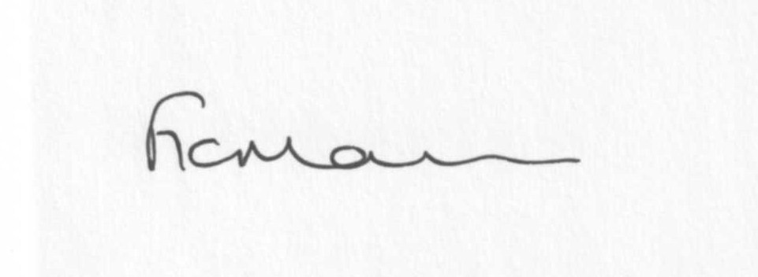
Mrs F Morris
Clerk to the Parish Council

AGENDA

0) Public participation
1) Apologies for absence
2) Casual Vacancy/signing of declaration of acceptance of office
3) Declaration of Interests
“To receive declarations of Interest of personal and prejudicial interest on any item on the agenda in accordance with Section 50-52 of the Local Government Act & The Local Authorities (Model Code of Conduct) England Order 2001”.
4) To confirm minutes of the meeting held on 26th September 2011 (copy attached)
5) Matters Arising from the minutes
a) Progress report (distributed at meeting)
b) Reply from SC re: Kennels bridge. Reply from SC /C Gittens re: Horse signs
c)Any other matters arising from minutes
6) Election of Vice-Chairman and Personnel Committee member
7) Planning applications:
a) Erection of an agricultural storage building for the storage of straw, machinery and fodder -
Raysland, Chorley – for information only
b) Erection of extension to side elevation following demolition of existing garage – Stanley Bungalow, Chorley
c) Any others received after issue of agenda
8) Correspondence:
Letter from Solicitors re: Glebe Drive land purchase
Queen’s Jubilee Beacons
LJC – agenda/papers for meeting 20th October Farlow & Oreton Village Hall 7pm
Arien Signs brochure
Emails (forwarded to Councillors):
ALC – Crash maps
Weekly Planning lists
ALC – Update re Parish Charter and future provision of IT services
Changes to local hospital services – meeting 15th November 7pm West side hall Oldbury Wells School
ALC – copy letter from Ryton X1 Towns re: future of IT provision
Rural Services Network newsletter
ALC – DIS Extra 769 document
ALC – Information re: Budgets/Precepts training; Blachere Illuminations; Code of recommended practice
ALC – SC Development Management briefing notes
ALC – Plastic bottle recycling in Bridgnorth area – roadshow dates/venues
Community Council Fuel Buying
ALC – ‘Local Works’
Any others received after the issue of the agenda
9) Parish matters/problems
a) Parish problems
b) Parish Watch
c) Parish Plan update
d) Diamond Jubilee
10) Financial matters:
a) Outstanding payments – Clerk’s fees/expenses. HMRC- PAYE. ALC account. ICO renewal. Any others received after issue of agenda.
b) Income since last meeting (distributed at meeting)
c) Quarterly bank reconciliation/budget – distributed at meeting
11) ALC report
12) Shropshire Councillor’s report
13) Road name signs
14) Items for next agenda
15) Date of next meeting – 28th November 2011

