
Stottesdon and Sidbury Parish Council
Clerk: Mrs Freda Morris
18 Glebe Drive
Stottesdon
Kidderminster
Worcs
DY14 8UF

Telephone: 01746 718453
E-mail: stottesdonpc@btinternet.com

Date: 18th June 2013
To: All Parish Council members
The Public and Press

A Parish Council meeting will be held on MONDAY 24th JUNE 2013 at 7.30pm in CHORLEY VILLAGE HALL for the transaction of business as set out in the agenda below, which you are summoned to attend.

Yours sincerely
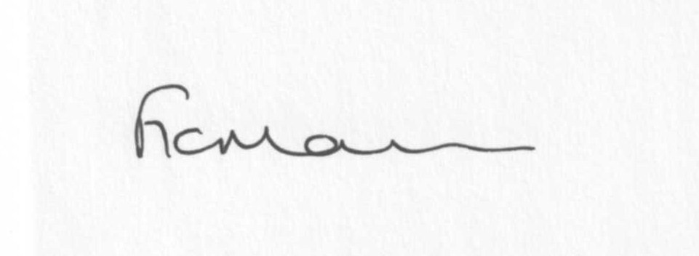
Mrs F Morris
Clerk to the Parish Council

AGENDA

0) Public participation
1) Apologies for absence
2) Declaration of Interests
The Localism Act 2011, Relevant Authorities (Disclosable Pecuniary Interests) Regulations 2012.
Members are reminded that they are required to leave the room during the discussion and voting on matters in which they have a disclosable pecuniary interest, whether or not the interest is entered in the register of member’s interests maintained by the Monitoring Officer.
3) Dispensations:
Requests for dispensations should be sent in writing to the Clerk prior to the meeting.
4) Co-option of Councillors
5) Signing of Councillors declarations of acceptance of office
6) To confirm minutes of the meeting held on 13th May 2013 (copy attached)
7) Matters Arising from the minutes
(a) Progress report: (distributed at meeting)
Reply from Oldbury Wells School and SC re: school bus/mini bus
(b) Any other matters arising
8) Planning applications
a) Reference: 13/02150/OHL(validated: 31/05/2013)
Address: Mass House Farm, Stottesdon, Kidderminster, Shropshire, DY14 8NL
Proposal: Erect an 11,000 volt overhead line on wood poles
Applicant: Western Power Distribution (FAO Miss Sam Akhar, Western Power Distribution, Riddings Road, Ludlow, Shropshire, SY8 1HR)
b) Any others received after issue of the agenda
c) Permissions granted:
Reference: 13/00450/FUL(validated: 06/02/2013)
Address: Pool Meadow Orchard, Harcourt Lane, Stottesdon, Shropshire, DY14 8UQ
Proposal: Erection of an agricultural building to service proposed orchard development and house agricultural equipment
Decision: Grant Permission

Reference: 13/00993/FUL(validated: 04/04/2013)
Address: The Duck Inn, Chorley, Bridgnorth, Shropshire, WV16 6PP
Proposal: Change of use of existing stables to commercial premises to include re-roofing
Decision: Grant Permission

Reference: 13/01202/FUL(validated: 28/03/2013)
Address: Raysland, Billingsley, Bridgnorth, WV16 6PF
Proposal: The erection of a garage/storage building (mixed agricultural and domestic use)
Decision: Grant Permission

Reference: 12/04836/FUL(validated: 21/11/2012)
Address: Firien Barn, Lower Bardley Court, Stottesdon, Kidderminster, DY14 8NE
Proposal: Erection of single storey front extension
Decision: Grant Permission

Reference: 13/01403/FUL (validated: 12/04/2013)
Address: Lower Harcourt, Chorley, Bridgnorth, Shropshire, WV16 6PP
Proposal: Renewal of extant Planning Permission 10/00775/FUL Erection of a replacement timber framed garage with storeroom following demolition of existing
Decision: Grant Permission
9) SALC report
10) Unitary Councillor’s report
11) Financial matters
a) Outstanding payments: Clerk’s fees, Viking Direct account, SALC account. Any others received after issue of agenda. To consider purchasing new edition of Local Council Administration book.
b) Income since last meeting (list distributed at meeting)
c) Internal Auditor’s report
d) Accounts - audit form completion
e) Bank statement/signatories
12) Parish matters/problems
a) Parish problems
b) Parish Watch
13) Correspondence:
Emails forwarded to Councillors:
Weekly Planning Lists
Rural Services Network newsletters
SC – Speeding Restrictions, Chorley
SALC – Shropshire Draft Dog Control Orders
Letter from Playgroup re: donation
Receipt from LCR
SALC – Community Stakeholders Questionnaire
Insurance renewal receipt/documents
SC – Prescott Bridge repairs
SC – Traffic Management Act 2004 (TMA) Part 3 – Consultation for West and Shires Permit Scheme for Highway Works
Lloyds TSB – changes to business accounts
LCR magazine
E-on letter re: highway lighting
Any others received after the issue of the agenda
14) Newsletter distribution
15) Date of next meeting – 22nd July 2013
16) Parking and Playing field – any updates received*
* Due to the confidential nature of the business to be discussed under item 16 the public and press shall be excluded under s1 (2) Public Bodies (Admission to Meetings) Act 1960 as amended.

