
Stottesdon and Sidbury Parish Council
Clerk: Mrs Freda Morris
18 Glebe Drive
Stottesdon
Kidderminster
Worcs
DY14 8UF

Telephone: 01746 718453
E-mail: stottesdonpc@btinternet.com

Date: 15th June 2014
To: All Parish Council members
The Public and Press

A Parish Council meeting will be held on MONDAY 23rd JUNE 2014, at 7.30pm in CHORLEY VILLAGE HALL for the transaction of business as set out in the agenda below which you are summoned to attend.

Yours sincerely

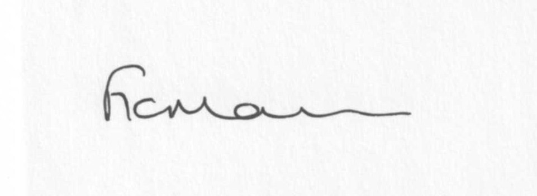
Mrs F Morris
Clerk to the Parish Council

AGENDA

0) Public participation (maximum 15 minutes)
1) Apologies for absence
2) Declaration of Interests
The Localism Act 2011, Relevant Authorities (Disclosable Pecuniary Interests) Regulations 2012.
Members are reminded that they are required to leave the room during the discussion and voting on matters in which they have a disclosable pecuniary interest, whether or not the interest is entered in the register of member’s interests maintained by the Monitoring Officer.
3) To confirm minutes of the meeting held on May 19th 2014 (copy attached)
4) Matters Arising from the minutes
(a) Progress report (distributed at meeting)
(b) Reply from SC re: Winterburn/Overton Road and Proposed works in parish
(c) Reply from SC re: HGV sign
(d) Reply from SC re: Bagginswood road complaint/reply from Ms Wagner
(e) Reply from SC re: Trees, Rosebank
(f) Any other matters arising
5) Chancel Repair Liability update – letter from Rev Resch
6) Planning applications:
Reference: 14/01709/FUL (validated: 04/06/2014)
Address: The Crest, Chorley, Bridgnorth, Shropshire, WV16 6PP
Proposal: Erection of a single storey orangery to rear
Applicant: Mr Tom Casswell

Reference: 14/02234/FUL (validated: 11/06/2014)
Address: 4 High Street, Stottesdon, Kidderminster, Shropshire, DY14 8TZ
Proposal: Demolition of damaged wall; re-building of 1.4m high boundary wall to front
Applicant: Mr David King

b) Any others received after issue of agenda

c) Planning permissions/refusals:
Reference: 12/04279/FUL (validated: 26/10/2012)
Address: Upper Northwood Farm, Northwood Lane, Northwood, Stottesdon, Shropshire, WV16 6PT
Proposal: Conversion of 2 redundant farm buildings to 4 residential units; alterations to existing vehicular access; installation of foul drainage system
Decision: Grant Permission

7) SALC report
8) Unitary Councillor’s report
9) Financial matters:
a) Outstanding payments: Clerks fees/HMRC PAYE/expenses, SALC training account. Any others received after issue of the agenda
b) Income since last meeting - confirmed at meeting
c) Bank statement
d) Year end Accounts/Internal Audit report/Annual return completion
10) Parish matters/problems
a) Parish problems
b) Parish Watch
11) Co-option – new Councillor?
12) Standing Orders/Financial Regulations update following training session 16/6/14
13) Correspondence:
Emails forwarded include:
SALC Bulletins
RSN newsletters
Shropshire Rural Hub newsletter
SC – alterations to electoral roll
Insurance Policy/receipt
SALC – response from Nick Boles, Planning Minister
Mr Kelsey – blocked drain at The Square/reply from SC
Chorley Show sign request for information/SC reply
SALC – Connecting Shropshire Broadband update
Report on the Bus User’s meeting in Bridgnorth
SALC – chairmanship training – 15th July 6.30pm-9pm, Shirehall
Any others received after issue of the agenda
14) Planning site visits
15) Community litterpick
16) Date of next meeting: July 28th 2014.
17) Update: Car parking/playing field ** - if anything to report.
**Due to the confidential nature of the business to be discussed under item 17 the public and press shall be excluded under s1 (2) Public Bodies (Admission to Meetings) Act 1960 as amended

