
Stottesdon and Sidbury Parish Council
Clerk: Mrs Freda Morris
18 Glebe Drive
Stottesdon
Kidderminster
Worcs
DY14 8UF

Telephone: 01746 718453
E-mail: stottesdonpc@btinternet.com

Date: 15th January 2012
To: All Parish Council members
The Public and Press

A Parish Council meeting will be held on MONDAY 23rd JANUARY 2012 at 7.30pm in CHORLEY VILLAGE HALL for the transaction of business as set out in the agenda below.

Yours sincerely

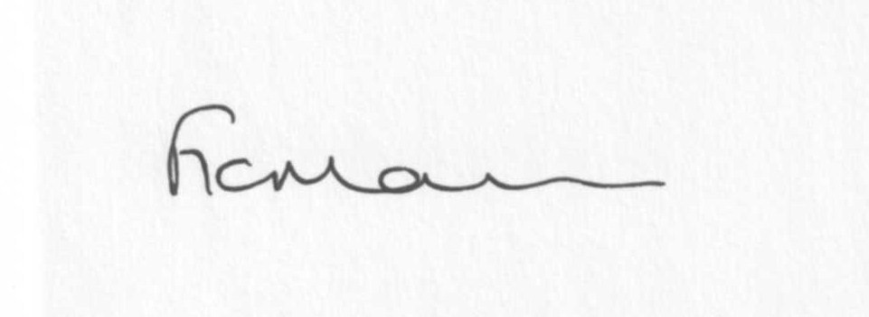

Mrs F Morris
Clerk to the Parish Council

AGENDA

0) Public participation
1) Apologies for absence
2) Declaration of Interests
“To receive declarations of Interest of personal and prejudicial interest on any item on the agenda in accordance with Section 50-52 of the Local Government Act & The Local Authorities (Model Code of Conduct) England Order 2001”.
3) To confirm minutes of the meeting held on 19th December 2011 and 5th January 2012(copy attached)
4) Matters Arising from the minutes
(a) Progress report (distributed at meeting)
(b) Any other s
5) Parish Plan update
6) To consider Chorley Family Playgroup and Stottesdon School funding requests
7) Planning applications: a) Any received after issue of the agenda
b) Permissions/refusals
8) Correspondence:
SC – Copy of Members Interest form – Cllr Bunn
SC – Precept requirement form
SC – Electoral Roll update
Planning Inspectorate –FP6 , Lower Chorley Farm – Order confirmed by Inspector
Crucial Crew financial request
Emails:
20/12 ALC – December Parish Pump/DIS Extra 774/Chairman’s Bulletin
20/12 ALC – New Legal Guidance – (Government Discretionary Payments) Regs 1996
22/12 Weekly Planning List
23/12 ALC – Planning – Affordable Homes
23/12 SC – Horse sign Sidbury
25/12 Reply from chairman re: Affordable Homes email 23/12/11
26/12 Rural Services Network (RSN) newsletter
3/1/12 “ “ “ “
3/1 Sustainable Gov – 8 ways to stop email killing productivity in 2012 part 1
6/1 Weekly planning list
9/1 RSN – newsletter
9/1 SC – road closure – Hinton/Loughton road
10/1 SC – road closure – Sidbury
10/1 SC – Annual ROW, parks and countryside sites survey for SC
10/1 Sustainable Gov – Don’t slip up...start 2012 as you mean to go on
10/1 ALC – Flood and water management Act 2010 consultation
11/1 SC – Annual Town and Parish Emergency Planning Briefing
11/1 SC – Horse signs/speeding issues – Bagginswood
11/1 ALC – Information Bulletin
12/1 Sustainable Gov – State of the unions – Scotland seeks independence from the UK
13/1 SC – Weekly Planning list
14/1 Queen Elizabeth II Fields challenge
14/1 ALC – Mobile library changes
Any other correspondence/emails received after the issue of the agenda
9) Parish matters/problems
a) Parish problems
b) Parish Watch
10) Financial matters
a) Outstanding payments - Clerk’ fees, SLCC renewal, PAYE, any others received after issue of agenda
b) Income since last meeting (distributed at meeting)
c) Bank statement
d) Precept
11) Asset Register – copy attached 2011
12) Risk Assessment – copy attached 2011
13) SALC report
14) Shropshire Councillor’s report
15) Items for next agenda
16) Date of next meeting – 27th February 2012

