
Stottesdon and Sidbury Parish Council
Clerk: Mrs Freda Morris
18 Glebe Drive
Stottesdon
Kidderminster
Worcs
DY14 8UF

Telephone: 01746 718453
E-mail: stottesdonpc@btinternet.com

Date: 17th April 2012
To: All Parish Council members
The Public and Press

A Parish Council meeting will be held on MONDAY 23rd APRIL 2012 at 7.30pm in CHORLEY VILLAGE HALL for the transaction of business as set out in the agenda below which you are summoned to attend.

Yours sincerely
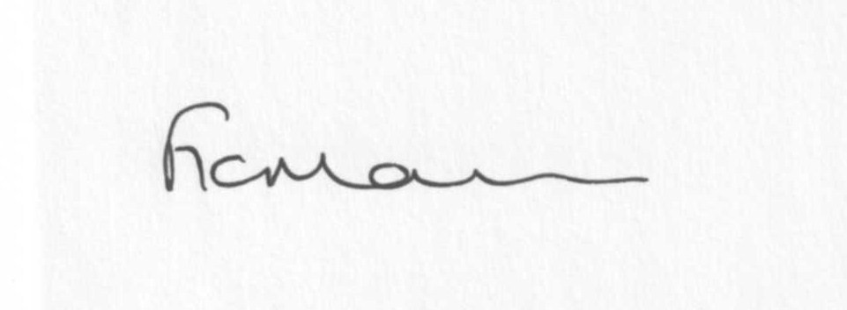

Mrs F Morris
Clerk to the Parish Council

AGENDA

0) Public participation
1) Apologies for absence
2) Declaration of Interests
“To receive declarations of Interest of personal and prejudicial interest on any item on the agenda in accordance with Section 50-52 of the Local Government Act & The Local Authorities (Model Code of Conduct) England Order 2001”.
3) To confirm minutes of the meeting held on 19th March 2012 (copy attached)
4) Matters Arising from the minutes
(a) Progress report (list distributed at meeting)
5) Planning applications:
a) Erection of two agricultural buildings (livestock, pen and implement food store unit) following
demolition of existing - Yew Tree Farm, Chorley
b) Any others received after issue of the agenda
c) Planning permissions – Manor House, Stottesdon. Any others received.
6) SALC report
7) Shropshire Councillor’s report
8) Financial matters
a) Outstanding payments – Clerk’s fees, ALC accounts, NALC account.
Donation requests: Samaritans, Marie Curie, Nightingale Nursing Fund, Pat Straughan RDA.
Any others received after issue of the agenda
b) Income since last meeting (list distributed at meeting)
c) Bank statement – year end reconciliation
9) Correspondence – includes emails forwarded to Councillors:
Came and Co – Queens Diamond Jubilee
Presentation to ALC – Shropshire Care Info Central
Weekly Planning Lists
Flood forum information
ALC Bulletins – weekly
A Jones – council tax increase
Bridgnorth Highways Office – change of address
SC – Shared Services
SC – paper prices
Information Bulletin – ALC
Reply re: Heresay
Rural Services Network newsletter
LJC – dates for future meetings
SC – Annual Town and Parish Emergency Planning Briefing
Learn how the academies programme is changing the education landscape
Lower Severn Corridor flood forum notes 29/3/12
Cllr Shineton – Torch update/meeting date
SC – Where to find the latest news from SC
D Sandbach – Getting services nearer to people who live in rural communities
ALC – bulletin
Rural Watch newsletter
Any others received after the issue of the agenda
10) Parish matters/problems
a) Parish problems
b) Parish Watch
c) Parish Plan
d) Jubilee celebrations
11) Community Asset Register
12) Place Plan
13) Date of next meeting – 21st May 2012 – Annual Parish Council meeting

