
Stottesdon and Sidbury Parish Council
Clerk: Mrs Freda Morris
18 Glebe Drive
Stottesdon
Kidderminster
Worcs
DY14 8UF

Telephone: 01746 718453
E-mail: stottesdonpc@btinternet.com

Date: 16thApril 2013
To: All Parish Council members
The Public and Press

A Parish Council meeting will be held on MONDAY 22nd APRIL 2013 at 7.30pm in CHORLEY VILLAGE HALL for the transaction of business as set out in the agenda below, which you are summoned to attend.

Yours sincerely

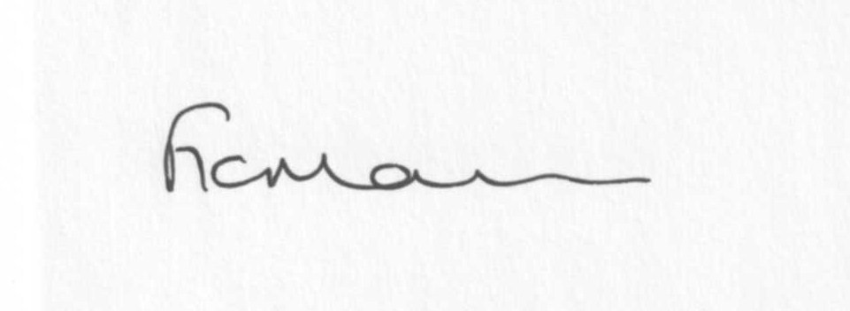

Mrs F Morris
Clerk to the Parish Council

AGENDA

0) Public participation
1) Apologies for absence
2) Declaration of Interests
The Localism Act 2011, Relevant Authorities (Disclosable Pecuniary Interests) Regulations 2012.
Members are reminded that they are required to leave the room during the discussion and voting on matters in which they have a disclosable pecuniary interest, whether or not the interest is entered in the register of member’s interests maintained by the Monitoring Officer.
3) Councillor’s dispensations
4) To confirm minutes of the meeting held on 25th March 2013 (copy attached)
5) Matters Arising from the minutes
(a) Progress report (distributed at meeting)
(b) Any other matters arising
6) Planning applications:
a) Reference: 13/00993/FUL(validated: 04/04/2013)
Address: The Duck Inn, Chorley, Bridgnorth, Shropshire, WV16 6PP
Proposal: Change of use of existing stables to commercial premises to include re-roofing
Applicant: Mrs S Clulee

b) Reference: 13/01202/FUL(validated: 28/03/2013)
Address: Raysland, Billingsley, Bridgnorth, WV16 6PF
Proposal: The erection of a garage/storage building (mixed agricultural and domestic use)
Applicant: W.J Jones And Company

c) Any others received after issue of agenda
d) Planning permissions/refusals
Reference: 13/00516/VAR (validated: 18/02/2013)
Address: Lower Chorley Farm, Chorley, Bridgnorth, Shropshire, WV16 6PP
Proposal: Application for the removal of Condition No.1 attached to Planning Permission reference 10/02054/COU to allow the continuation of the use of the workshop
Decision: Grant Permission
e) Planning enquiry re: Dormer windows
7) Financial matters
a) Outstanding payments:
Clerks fees.
Chorley Family Playgroup.
HMRC PAYE.
SALC account
Any others received after issue of agenda.
b) Year end accounts/Audit papers
c) Income since last meeting (confirmed at meeting)
8) SALC report
9) Shropshire Councillor’s report
10) Elections
11) Correspondence:
Including emails forwarded to Cllrs:
SALC – SC signs deal for faster broadband to County
Weekly Planning lists
RSN newsletters
School bus
SALC – SC Draft Contaminated Land Strategy consultation
SALC Bulletins
Hope House donation acknowledgment
Samaritans “ “
SALC - letter from HM Lord-Lieutenant for Shropshire
Came & Co – confirmation bus shelter added to insurance
Shropshire Hills Bulletin
SALC - Funding update from SC
SALC – Information leading up to elections 2nd May
Lower Severn Corridor Flood Forum agenda 22nd April 2013
Any others received after the issue of the agenda
12) Parish matters/problems
a) Parish problems
b) Parish Watch
13) Date of next meeting - 13th May 2013 – Annual Parish Council meeting
Due to the confidential nature of the business to be discussed under the Public Bodies (Admission to Meetings) Act 1960 and under s100 (A) of the Local Government Act 1972 the public and press shall be excluded for the remainder of the meeting for the following items of business on the grounds they may involve the likely disclosure of exempt information as defined by the Acts.

14) Parking – any update received

