
Stottesdon and Sidbury Parish Council
Clerk: Mrs Freda Morris
18 Glebe Drive
Stottesdon
Kidderminster
Worcs
DY14 8UF

Telephone: 01746 718453
E-mail: stottesdonpc@btinternet.com

Date: 13th October 2014 Please note change of date
To: All Parish Council members
The Public and Press

A Parish Council meeting will be held on TUESDAY 21^{to} OCTOBER 2014, at 7.30pm in CHORLEY VILLAGE HALL for the transaction of business as set out in the agenda below which you are summoned to attend.

Yours sincerely

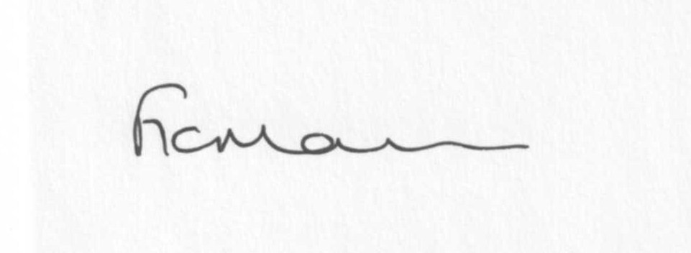
Mrs F Morris
Clerk to the Parish Council

AGENDA

0) Public participation (maximum 15 minutes)
1) Apologies for absence
2) Declaration of Interests
The Localism Act 2011, Relevant Authorities (Disclosable Pecuniary Interests) Regulations 2012.
Members are reminded that they are required to leave the room during the discussion and voting on matters in which they have a disclosable pecuniary interest, whether or not the interest is entered in the register of member’s interests maintained by the Monitoring Officer.
3) To confirm minutes of the meeting held on September 22nd 2014 (copy attached)
4) Matters Arising from the minutes
(a) Progress report (distributed at meeting)
(b) Reply from SC re: parish problems
(c)Any other matters arising
5) Planning applications:
a) Any received after issue of the agenda

b) Planning permissions/refusals:
Reference: 14/03840/FUL(validated: 05/09/2014)
Address: The Hawthorns, Chorley, Bridgnorth, WV16 6PP
Proposal: Erection of two storey and single storey rear extensions
Decision: Grant Permission

Reference: 14/03303/FUL (validated: 15/08/2014)
Address: Litley Oak, Chorley, Bridgnorth, Shropshire, WV16 6PP
Proposal: Erection of an outbuilding
Decision: Grant Permission

Reference: 14/04127/HRM (validated: 12/09/2014)
Address: Field to West of Scots House, Chorley, Bridgnorth, Shropshire,
WV16 6PR
Proposal: Removal of 75m of hedgerow to facilitate modern arable farming
Decision: Refuse

6) SALC report
7) Unitary Councillor’s report
8) Financial matters:
a) Outstanding payments: Clerks fees/HMRC PAYE/expenses, Data Protection renewal
Any others received after issue of the agenda
b) Income since last meeting - confirmed at meeting
c) Bank statement
d) Quarterly bank reconciliation/budget
9) Parish matters/problems
a) Parish problems
b) Parish Watch
c) Letter of complaint received from Mr & Mrs Swain re: newsletter item on Bonfires/Barking dogs
d) Complaint re: roads through Stottesdon and Rays Farm road (incomplete patch)
e) Complaint re: VAS, Station Road, Stottesdon
10) Co-option – confirmation from SC to co-opt new Councillors following expiry of advertising period
11) Correspondence:
Emails forwarded include:
SALC Bulletins
RSN newsletters
Rural Hub newsletter
SALC – Community Health Review 2014-09-15 Shropshire Housing Alliance – AGM 23rd October, 3-5pm at Shirehall - Reminder
SALC – Shropshire Urgent Care
SALC – Place Plan Review – Reminder
SALC AGM – 1st November – Reminder
SC - Outdoor Partnership newsletter
Severn Centre, Highley events
SALC – Community Transport survey
Shropshire Community Space Conference – 11th November
SC – Severe weather/potholing scheme – ongoing programme of planned road closures
SALC – Parish & Town Council briefing note on planning decisions 131014
Any others received after issue of the agenda
12) Date of next meeting: November 24th 2014.
13) Update: Car parking/playing field ** - if anything to report.
**Due to the confidential nature of the business to be discussed under item 13 the public and press shall be excluded under s1 (2) Public Bodies (Admission to Meetings) Act 1960 as amended

