
Stottesdon and Sidbury Parish Council
Clerk: Mrs Freda Morris
18 Glebe Drive
Stottesdon
Kidderminster
Worcs
DY14 8UF

Telephone: 01746 718453
E-mail: stottesdonpc@btinternet.com

Date: 12th May 2012
To: All Parish Council members
The Public and Press

The Annual Parish Council meeting will be held on MONDAY 21st MAY 2012 at 7.30pm in CHORLEY VILLAGE HALL for the transaction of business as set out in the agenda below which you are summoned to attend.

Yours sincerely

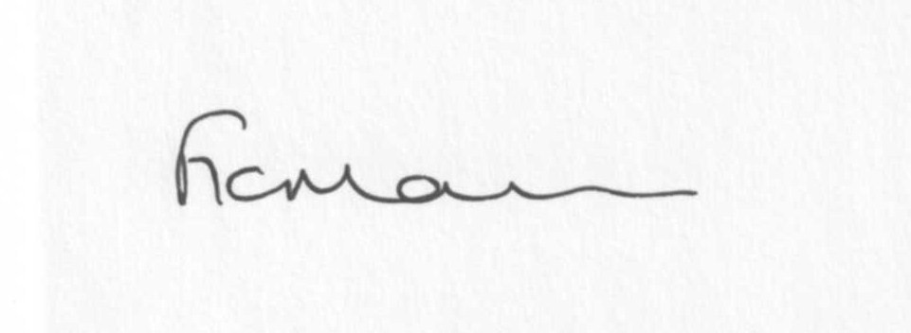
Mrs F Morris
Clerk to the Parish Council

AGENDA

0) Public participation
1) Election of Chairman
2) Signing of declaration of acceptance of office – Chairman
3) Election of Vice-Chairman
4) Signing of declaration of acceptance of office – Vice-Chairman
5) Election committees:
Personnel committee
Disciplinary and Grievance Committee
Any others required
6) Apologies for absence
7) Declaration of Interests
“To receive declarations of Interest of personal and prejudicial interest on any item on the agenda in accordance with Section 50-52 of the Local Government Act & The Local Authorities (Model Code of Conduct) England Order 2001”.
8) To confirm minutes of the meeting held on 23rd April, 2012(copy attached)
9) Matters Arising from the minutes
(a) Progress report (distributed at meeting)
(b) Bus shelter quotations
(c) Reply re school field enquiry
(d) SC – Enforcement re: dog fouling
10) Planning applications:
a) Proposed extension to provide new Reception office, general purpose room and playground
extension – Stottesdon CE Primary School – 12/01783/FUL
b) Erection of agricultural building for storage of machinery/feed and animal care; installation of 40PV solar panels to south roofline – Walnut Tree Cottage, Midwinters, Chorley – 12/01912/FUL
c) any others received after issue of the agenda
d) Planning permissions/refusals
11) Shropshire Councillor’s report
12) SALC Report
13) Financial matters:
a) Accounts to be paid: Clerk’s fees/expenses; Insurance renewal. Pat Straughan RDA letter. Any others received after issue of agenda
b) Approval of accounts up to year end 31st March 2012
c) Bank Statement
d) Income received since last meeting
e) HMRC overpayment notification
14) Correspondence (including emails forwarded to Councillors):
The Clerk magazine
Samaritans – donation confirmation
Historic Towns Forum (HTF) Community Asset Transfer event London 31st May £89 per delegate
HTF Newsletter
Queen Elizabeth II Fields challenge, Fields in Trust
Weekly Planning Lists
Came and Company – Guide to PC Insurance
Rural Service Network newsletters
ALC – early Day Motions on Planning Appeals and the Planning Applications (Appeals by parish and Town Councils) Bill
SAMDev Public Consultation – extension and deadline PLUS Consultation of the Implementation of Amendments to the reservoirs Act 1975
ALC – Supporting Communities and Neighbourhood
Tracy Johnson – Broadband campaign launch
“ “ Train the Trainer training – 16th May Severn Centre, Highley
Cllr Shineton – Olympic Torch Action Plan update
Mrs and Mrs Swain – complaint re: footpath obstruction/poor maintenance, Chorley
2012 Rural insight survey
Time for T – Teenage Cancer Trust
Shropshire Gov – Start of conversion programme to part-night lighting
Linda Jeavons – Super Broadband
David Ramsbotham – Wind turbines
DEFRA – Funding round 2 open for high speed broadband funding
Any others received after issue of the agenda
15) Parish matters/problems
a) Parish problems
b) Parish Watch
c) Parish Plan update
16) Date of next meeting – 25th June 2012

