
Stottesdon and Sidbury Parish Council
Clerk: Mrs Freda Morris
18 Glebe Drive
Stottesdon
Kidderminster
Worcs
DY14 8UF

Telephone: 01746 718453
E-mail: stottesdonpc@btinternet.com

Date: 11th December 2011 Please note change of time
To: All Parish Council members
The Public and Press

A Parish Council meeting will be held on MONDAY 19th DECEMBER 2011 at 7.00pm in CHORLEY VILLAGE HALL for the transaction of business as set out in the agenda below.

Yours sincerely

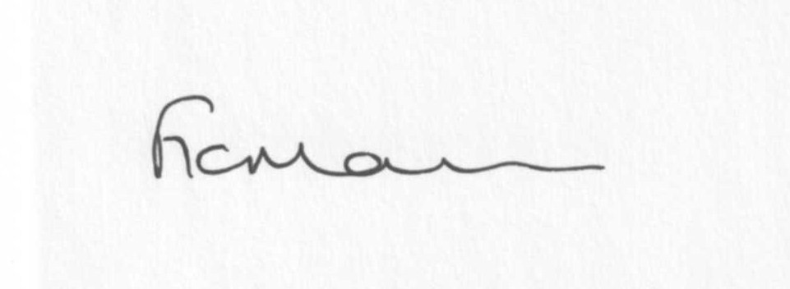

Mrs F Morris
Clerk to the Parish Council

AGENDA

0) Public participation
1) Apologies for absence
2) Declaration of Interests
“To receive declarations of Interest of personal and prejudicial interest on any item on the agenda in accordance with Section 50-52 of the Local Government Act & The Local Authorities (Model Code of Conduct) England Order 2001”.
3) To confirm minutes of the meeting held on 28TH November 2011 (copy attached)
4) Matters Arising from the minutes
(a) Progress report (list distributed at meeting)
5) Planning applications:
a) Erection of a single storey front extension – Firien Barn, Lower Bardley Court, Bagginswood
b) Erection of a two storey extension to side elevation – Bardley Cottage, Bagginswood
c) Any others received after issue of agenda
d) Permissions/refusals
6) Stottesdon School
7) Chorley Family Playgroup
8) SamDev response – DRAFT copy attached
9) Parish Plan update
10) Correspondence:
Emails:
28/11 Came and Company – ERN number request
29/11 SALC – The Localism Act – Standards and the Members Code of Conduct
30/11 SC – Planning decision Peggs Barn – permission granted
1/12 SC – Confirmation 0f receipt of ‘expression of interest’ documents re: Stotty Shop
1/12 Receipt from Chorley Chapel re: Burial grant
2/12 Planning lists
2/12 SALC Information Bulletin
2/12 SC reply re: HORSE signs
5/12 Rural Services Network newsletter
5/12 Litter problem query
5/12 SC Electoral Roll
6/12 SC –CIL Charging Schedule – approved
6/12 Order confirmation re; Jubilee coins
6/12 Sustainable Government protecting data and the trust of the public
7/12 Tracey Johnson – Sported
8/12 CAB – acknowledgement of donation
9/12 SC Planning lists
9/12 SALC – Membership survey
9/12 SALC – Information Bulletin
Any others received after the issue of the agenda - updated at meeting
11) Parish matters/problems
a) Parish problems
b) Parish Watch
12) Financial matters
a) Outstanding payments: Clerk’s fees and expenses, SALC account, coins for electricity.
Any others received after issue of agenda.
b) Income since last meeting
c) Precept
d) Bank statement
13) SALC report
14) Shropshire Councillor report
15) Street Name signs
16) Items for next agenda
17) Date of next meeting - 23rd January 2012

Please note:
Deadline for items for newsletter is 12 noon on January 4th 2012

